Hermite polynomials

Def

$$He_{n}\left(x\right)$$

= $${\left(−1\right)}^{n}e^{\frac{x^{2}}{2}}⋅\frac{d^{n}}{dx^{n}}e^{−\frac{x^{2}}{2}}$$

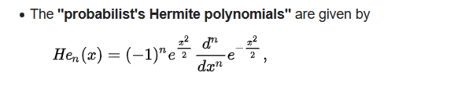

$$H_{n}\left(x\right)$$

= $${\left(−1\right)}^{n} ⋅ e^{x^{2}}⋅\frac{d^{n}}{dx^{n}}\left(e^{−x^{2}}\right)$$

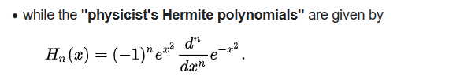

$$He_{n}\left(x\right)$$

= $${\left(x−\frac{d}{dx}\right)}^{n}⋅1$$

$$H_{n}\left(x\right)$$

= $${\left(2x−\frac{d}{dx}\right)}^{n}⋅1$$

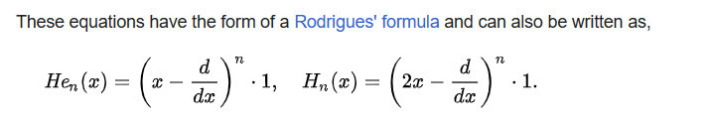

$$H_{n}\left(x\right)$$

= $$2^{\frac{n}{2}}He_{n}\left(2^{\frac{1}{2}}x\right)$$

=>

$$He_{n}\left(x\right)$$

= $$2^{−\frac{n}{2}}⋅H_{n}\left(\frac{x}{2^{\frac{1}{2}}}\right)$$

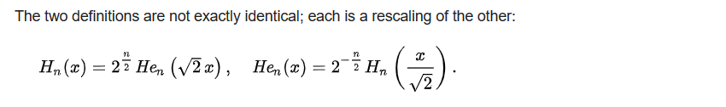

Value

For 0th to 10th element, the hermite polynomials in probability and it in physicals

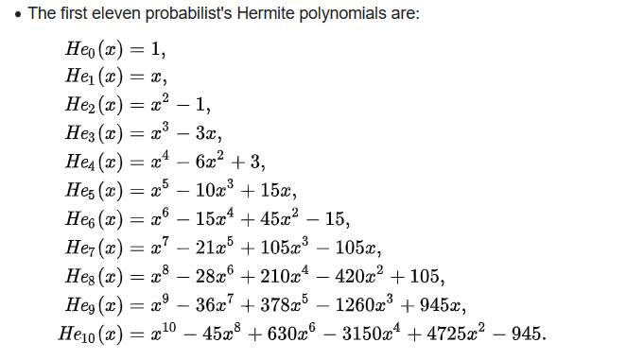

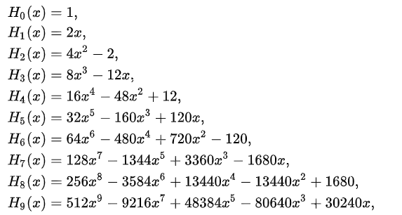



Bürmann series

$$erf\left(z\right)$$

= $$\frac{2}{pi{\left(\right)}^{\frac{1}{2}}}⋅sgn\left(z\right)⋅{\left(1−e^{−x^{2}}\right)}^{\frac{1}{2}}$$

$$⋅\left[1−\frac{1}{12}\left(1−e^{−x^{2}}\right)−\frac{7}{480}⋅{\left(1−e^{−x^{2}}\right)}^{2}−\frac{5}{896}{\left(1−e^{−x^{2}}\right)}^{3}−\frac{787}{276840}{\left(1−e^{−x^{2}}\right)}^{4}−…\right]$$

= $$sigma\left(\frac{2}{pi{\left(\right)}^{\frac{1}{2}}}\right)⋅sgn\left(z\right)⋅{\left(1−e^{−x^{2}}\right)}^{\frac{1}{2}}$$

$$\left(\frac{pi{\left(\right)}^{\frac{1}{2}}}{2}+sigma\left(c_{k}e^{−kz^{2}},k=1,k=\inf{}\right)\right)$$

If one chooose $$c_{1}$$ = $$\frac{31}{200}$$ $$c_{2}$$ = $$−\frac{341}{8000}$$ the result will approximate to

$$erf\left(z\right)$$

= $$\frac{2}{pi{\left(\right)}^{\frac{1}{2}}}⋅sgn\left(z\right)⋅\left(1−e^{−x^{2}}\right)⋅\left(\frac{pi{\left(\right)}^{\frac{1}{2}}}{2}+\frac{31}{200}e^{−x^{2}}−\frac{341}{8000}e^{−2x^{2}}\right)$$

Inverse functions

With Maclaurin series,

$$erf^{−1}\left(z\right)$$

= $$sigma\left(\frac{c_{k}}{2k+1}{\left(\frac{pi{\left(\right)}^{\frac{1}{2}}}{2}⋅z\right)}^{2k+1},k=0,k=\inf{}\right)$$

where

$$c_{0}$$

= $$1$$

and

$$c_{k}$$

= $$sigma\left(\frac{c_{m}c_{k−1−m}}{\left(m+1\right)\left(2m+1\right)},m=0,m=k−1\right)$$

for all $$k>0$$ and $$k$$ is an integer.

For more details, see Wiki given in Ref section.

Ref

[Hermite polynomials - Wikipedia](https://en.wikipedia.org/wiki/Hermite_polynomials)